Problem statement
Despite widespread digital adoption, password security remains a major weakness in many systems. Users frequently create weak passwords, reuse credentials across platforms, and rely on insecure storage practices.
Many applications either store passwords improperly or fail to educate users about how passwords can be compromised through attacks such as brute force or dictionary-based cracking. This creates a gap between theoretical cybersecurity knowledge and practical understanding.
There is a need for a beginner-friendly tool that not only demonstrates secure password storage using modern cryptographic techniques but also illustrates how weak passwords can be exploited in real-world scenarios.

Abstract
- With the increasing reliance on digital platforms, secure password management has become a critical aspect of cybersecurity.
- Dr. Vault is a desktop-based cybersecurity application developed to demonstrate secure password storage and basic password cracking techniques.
- The application integrates secure authentication using bcrypt hashing, encrypted password storage using AES.
- the tool also includes a lab that demonstrates practical password attacks such as brute force, dictionary attacks, and rainbow table lookups – everything implemented in an easy to use GUI interface built by python

Theories, concepts, Technology:-

Tech stack explanations
What is PySide6?
PySide6 is the official Python binding for the Qt framework, used to build modern desktop applications with native look and feel.
It enables developers to create:
- Cross-platform desktop apps (Windows, Linux, macOS)
- Event-driven GUIs
- Complex widgets and layouts
Why Used in This Project
- To create a professional desktop interface
- Implemented:
  - Login system
  - Sidebar navigation
  - Multi-tab hash lab

Key Features Used
- QWidget-based UI design
- QStackedWidget for multi-page navigation
- QThread for background cracking workers

Benefits
- Native performance
- Professional UI capability
- Strong threading support
- Scalable architecture

SQLite (Database)
What is SQLite?
SQLite is a lightweight, server less relational database engine stored as a single local file.
Unlike MySQL/PostgreSQL:
- No server required
- Embedded directly in application
Why Used
- Ideal for local secure storage
- Simple deployment
- No external dependencies

Role in Project
Two tables implemented:
Users Table
Stores:
- Username (Primary key)
- bcrypt password hash
- Salt
Vault Table
Stores:
- Encrypted credentials
- Owner mapping
- Timestamp metadata

Advantages
- Zero configuration
- Fast local access
- ACID-compliant transactions (Atomicity Consistency Isolation Durability)
- File-based portability

What is bcrypt?
bcrypt is a password hashing algorithm specifically designed to securely store passwords.
It is based on:
- Blowfish cipher
- Adaptive hashing (configurable cost factor)
Unlike normal hashes (MD5, SHA):
bcrypt is intentionally slow to resist brute force attacks.

How bcrypt Works
Step 1 — Salt Generation
A random salt is generated:
- Prevents rainbow table attacks
- Ensures identical passwords produce different hashes
Step 2 — Cost Factor
bcrypt applies multiple rounds of hashing:
- Work factor (e.g., 2^12 rounds)
- Adjustable security level
Step 3 — Hash Output
Final hash contains:
- Algorithm identifier
- Cost factor
- Salt
- Hash value

Security Strength
bcrypt is considered:
- Industry standard for password storage
- Resistant to:
  - Rainbow tables
  - GPU attacks (due to slow design)

Why Used in Project
- Secure authentication layer
- Prevents plaintext password storage
- Demonstrates real-world password security
AES (Advanced Encryption Standard)
What is AES?
AES is a symmetric encryption algorithm used worldwide for secure data encryption.
It operates on:
- Fixed block size (eg. 128-bit blocks)
- Key sizes:
  - AES-128
  - AES-192
  - AES-256
This project uses AES-256 equivalent strength via 32-byte keys.

How AES Works (Simplified)
AES performs multiple rounds of:
- Substitution
- Permutation
- Mixing
- Key addition
Each round increases diffusion and confusion, making ciphertext extremely difficult to reverse without the key.

What is AES-GCM?
GCM = Galois/Counter Mode
It provides:
Encryption
Authentication
Integrity verification
This makes it an AEAD mode (Authenticated Encryption with Associated Data).
What is PBKDF2?
Password-Based Key Derivation Function 2
Used to convert:
Weak passwords → Strong cryptographic keys

Why Needed
Human passwords are weak.
AES requires high-entropy keys.
PBKDF2:
- Adds salt
- Performs thousands of iterations
- Produces strong 256-bit keys

Security Benefits
- Slows brute force attacks
- Prevents rainbow table attacks
- Industry standard (used in WPA2, PKCS#5)
Hashing Utilities (SHA Family + MD5)
The project supports:
- SHA-256
- SHA-512
- MD5

SHA-256 / SHA-512
- Cryptographic hash functions
- One-way irreversible functions
- Used in:
  - Blockchain
  - Digital signatures
  - Password storage (legacy systems)

MD5
Included for educational comparison:
- Very fast
- Broken cryptographically
- Demonstrates weak hash vulnerabilities

Base64 Encoding (Utility Feature)
Used for:
- Binary-to-text conversion
- Safe storage/transmission

Multithreading (QThread Workers)
The cracking engine uses:
- Background threads
- Non-blocking GUI
This enables:
- Real-time progress updates
- Smooth UI experience
- Safe concurrent execution

Encoding Vs Hashing Vs Encryption –
Encoding:
Encoding is the process of converting data, information, or signals into a specific format for efficient transmission, storage, or processing. It translates human-readable characters, audio, or video into digital formats (binary) that machines can understand, or converts information into a standardized format for secure transfer, such as URL encoding. It changes representation (format) without hiding meaning of the original text.
Example: convert binary bytes into printable ASCII with Base64 so you can send it in email or JSON safely.
How it works (examples)
- Base64: groups input bits and maps to 64 printable characters. Reversible: decode to original bytes.
- URL percent-encoding: encode unsafe characters in URLs (%20 for space).
- Character encodings: UTF-8, UTF-16 map characters to bytes—this is encoding, not cryptography.
Why/when used
- Passing binary data over text-only channels (email, JSON).
- Ensuring consistent byte representation (text encodings) across systems.
- Not for secrecy — do not treat Base64 or character encoding as encryption.
Reversibility
- Reversible; any system that knows the encoding can decode back to original.

Hashing:
Core properties of a cryptographic hash function
- Deterministic: same input → same digest (output).
- Fixed-length output: e.g., 256 bits for SHA-256.
- Preimage resistance: given digest, infeasible to find original input.
- Second-preimage resistance: given input A, infeasible to find B ≠ A with same digest.
- Collision resistance: infeasible to find any two inputs with same digest.
Important: “infeasible” is about computational cost against current technology — as computing power rises or math advances, properties can be broken (see SHA-1).
Typical uses
- Message integrity (detect accidental or malicious changes).
- Digital signatures: sign hash of document rather than whole doc.
- Password storage: store hashes (with salt and slow KDF) instead of plaintext.
- Deduplication / data structures: content-addressable storage (Git uses SHA family historically).
- Merkle trees, blockchain: hash chaining.
Password hashing vs general hashing
General-purpose hashes (SHA-256) are fast — not good for password storage because attackers can brute-force quickly with GPUs/ASICs. For passwords you need purpose-built slow, memory-hard password hashing functions (PBKDFs / KDFs) to increase attacker cost.
Password hashing algorithms (current best practice)
- Argon2 (Argon2id recommended): winner of the Password Hashing Competition (PHC). Memory-hard and tunable (time, memory, parallelism). Widely recommended for new systems. (OWASP recommends Argon2; see citations.) OWASP.
- bcrypt: older, still used in many systems. Good, but limited (32-bit salt, 72-byte input limit, less memory hardness). Still acceptable for legacy but prefer Argon2.
- scrypt: memory-hard (older than Argon2), still reasonable but Argon2 usually preferred.
- PBKDF2: NIST-approved KDF, widely used (e.g., many protocols). Use with sufficient iteration counts. Good but less resistant to modern GPU/ASIC attacks than Argon2 for the same CPU cost.
General-purpose hash algorithms (integrity, signatures)
- SHA-2 family (SHA-256, SHA-384, SHA-512) — standard, widely used and secure today.
- SHA-3 (Keccak) — alternative with different internal design; modern standard.
- BLAKE2 / BLAKE3 — very fast secure hashes; BLAKE3 is newer and optimized for parallelism and speed.
- Broken/Deprecated: SHA-1 and MD5 — practical collision attacks demonstrated (SHA-1 collision announced in 2017). Do not use SHA-1 for security-sensitive purposes.
When hashing is one-way vs reversible
- Cryptographic hashes are designed to be one-way. However:
  - Short or low-entropy inputs (like passwords) can be brute-forced (rainbow tables, dictionary attacks) unless you use salts and slow KDFs.
  - If attacker can brute force all possible inputs, then the hash is effectively reversible (by enumeration). So use salt + memory/time work factor.
Salts, pepper, and KDFs
- Salt: unique random per-password value stored with the hash; protects against precomputed rainbow tables and enables per-user uniqueness.
- Pepper: secret value stored separately (e.g., in HSM) — adds defense but complicates operational management.
- Use KDFs like Argon2/PBKDF2/scrypt/bcrypt to make verification intentionally expensive.
Encryption — deep dive (symmetric, asymmetric, AEAD, key mgmt)
Symmetric encryption
- Same key used to encrypt and decrypt. Faster and suitable for large data volumes.
- Common algorithms / modes:
  - AES (Advanced Encryption Standard) — block cipher; use in AEAD modes (e.g., AES-GCM, AES-GCM-SIV). AES-256 gives higher margin.
  - ChaCha20-Poly1305 — stream cipher + authenticator; performs very well in software (mobile/ARM) and is a strong alternative to AES-GCM. RFC for ChaCha20-Poly1305 exists. IETF.
Important: use AEAD (Authenticated Encryption with Associated Data) constructions (like AES-GCM, ChaCha20-Poly1305). AEAD gives confidentiality + authenticity (integrity) in one primitive and prevents common misuse.
Asymmetric / public-key encryption
- Different keys: public key (encrypt or verify) and private key (decrypt or sign). Slower, used for key exchange, signatures, small messages.
- Common algorithms:
  - RSA (widely used historically). For encryption/signature use strong key sizes (e.g., ≥3072-bit for long-term security as of now).
  - Elliptic-curve cryptography (ECC): secp256r1 (P-256), secp384r1, Ed25519 (signatures), X25519 (key agreement) — typically smaller keys, better performance.
  - Post-quantum algorithms: NIST has been standardizing PQC algorithms (see below).
Key exchange / TLS
- Modern TLS uses ephemeral Diffie-Hellman (ECDHE) for forward secrecy and AEAD ciphers for record encryption. TLS cipher suites choose key exchange (ECDHE), auth (RSA, ECDSA), and AEAD (AES-GCM, ChaCha20-Poly1305).
Key management (brief, but crucial)
- Keys must be generated securely, stored securely (HSMs, OS key stores), rotated, and access-controlled. Weak key management ≫ strong algorithm choices in causing compromise.
Reversibility
- Encryption is reversible only with the correct key; without the key, ciphertext should be computationally infeasible to decrypt.

Hashing | Encryption | Encoding
One-way conversion of data into a fixed-length value. | Converts plaintext into ciphertext using a key (reversible). | Converts data to another format for compatibility (reversible).
Used for integrity verification and password storage. | Used for confidentiality and secure communication. | Used for data formatting, transmission, and storage.
Cannot be reversed only compared. | Can be reversed using the correct key. | Can be reversed without any key.
Produces fixed-size output. | Output is same size or larger than input. | Output often becomes larger than input.
No secret key required. | Requires encryption & decryption keys. | No key required.
Examples: MD5, SHA-256. | Examples: AES, RSA. | Examples: Base64, URL Encode.

Industry standards & the “latest” secure algorithms (what to pick today)
Hashing & password storage
- Argon2id — recommended default for new password storage (memory-hard, tunable).
- bcrypt — acceptable for legacy systems; still widely used, but less ideal than Argon2.
- scrypt — good memory-hard alternative.
- PBKDF2 — NIST-approved; still in use (e.g., some protocols), but requires high iteration counts.
General hashing (integrity / signatures)
- SHA-2 family (SHA-256 / SHA-384 / SHA-512) — mainstream and secure now.
- SHA-3 (Keccak) — alternative standardized by NIST.
- BLAKE2 / BLAKE3 — modern fast hashes; BLAKE3 is newer and very fast.
Symmetric encryption & AEAD
- AES-GCM — widely deployed, hardware acceleration (AES-NI) makes it very fast on many servers. Use correct IV/nonce management.
- ChaCha20-Poly1305 — excellent for mobile/embedded and in environments without AES hardware acceleration. RFC standardized.
Public-key & signatures
- Ed25519 / X25519 — modern ECC choices for signatures and key agreement, respectively. Good defaults for new systems.
- RSA — still used for compatibility; prefer 3072-bit or higher for long-term security.
Post-quantum cryptography (PQC) — high-level (why it matters)
- Because quantum computers could in theory break RSA & ECC (Shor’s algorithm), NIST ran a PQC standardization process and selected quantum-resistant algorithms (e.g., CRYSTALS-Kyber for KEM; CRYSTALS-Dilithium and others for signatures) in 2022–2024 and produced first PQC standards. Systems with long-term confidentiality requirements should plan crypto-agility and a migration path.

Where each is used — concrete scenarios
Encoding
- HTTP bodies (Base64 attachments), web forms, JSON fields, text protocols.
Hashing
- Passwords: store salted argon2/bcrypt hashes. (OWASP guidance.)
- File integrity: SHA-256 digests on downloads (signed with a signature algorithm).
- Checksums: deduplication, content-addressed storage (Git historically used SHA-1 earlier; modern systems use SHA-256 or similar).
- Digital signatures: sign a digest rather than whole document.
Encryption
- Transport security: TLS — uses asymmetric cryptography for handshake and symmetric AEADs to encrypt traffic (e.g., AES-GCM, ChaCha20-Poly1305).
- At-rest encryption: disk encryption (LUKS, BitLocker), database encryption (TDE), object store server-side encryption. AES (XTS, GCM) variants commonly used.
- End-to-end messaging: Signal protocol (double ratchet) uses Diffie-Hellman, X25519, and AEADs.
- Key wrapping / KMS: encrypt keys with master keys in HSM/KMS.

Execution Architecture Diagram
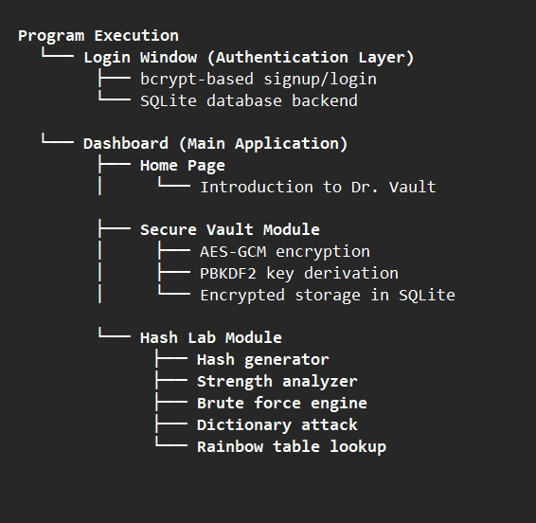

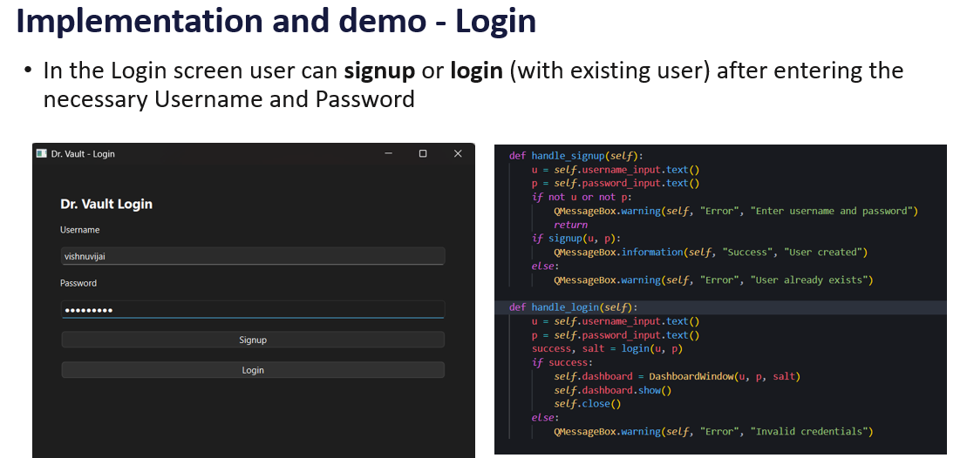

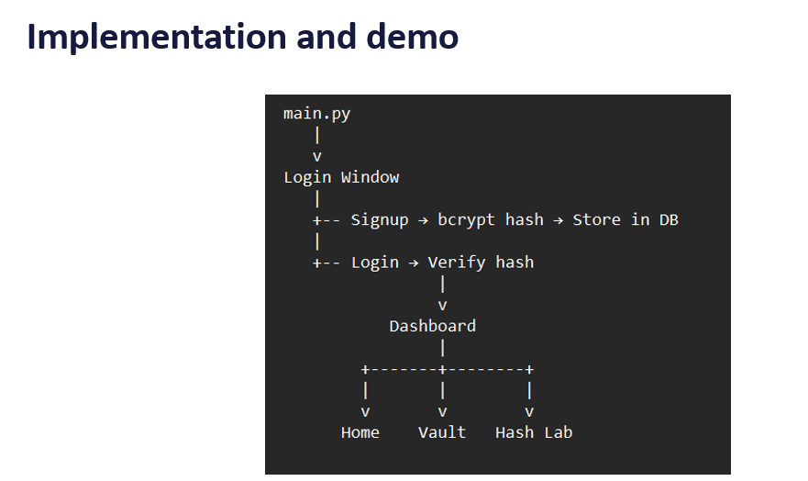

Dashboard Demo Home page
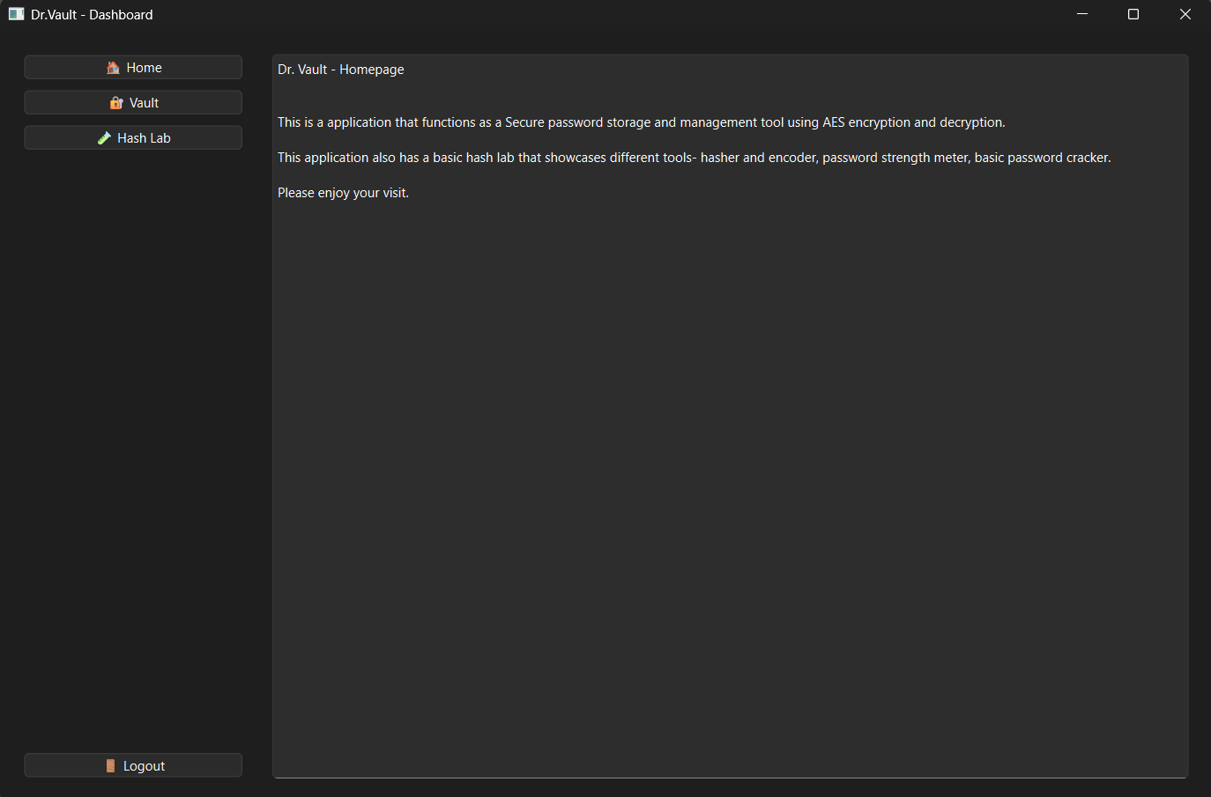
As shown, the implementation is done using split pane format so one can navigate within the application.
On the left pane there are – Home, Vault, Lab.
The Home is a intro page
The Vault is the place where the password storage takes place
The Hash Lab indicated is the mini lab that will provide hash function, password strength analyzer, and dictionary and rainbow table attack
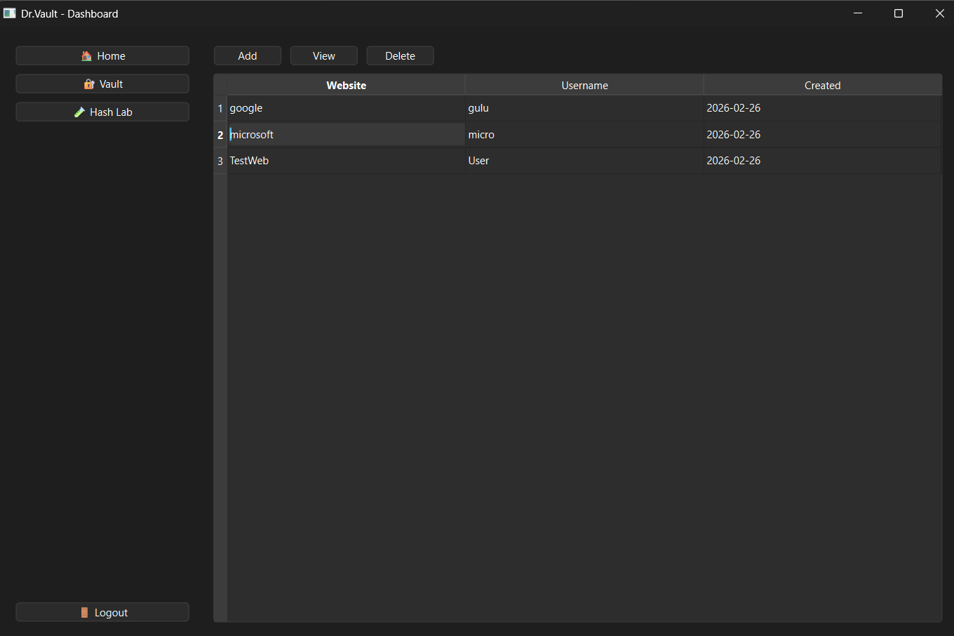

The Vault Tab
This tab contains the Vault section
were the user’s data and password is stored.
It has buttons – Add, View, and Delete
The data stored involves Website name, username, Creation date along with the AES Encrypted stored password

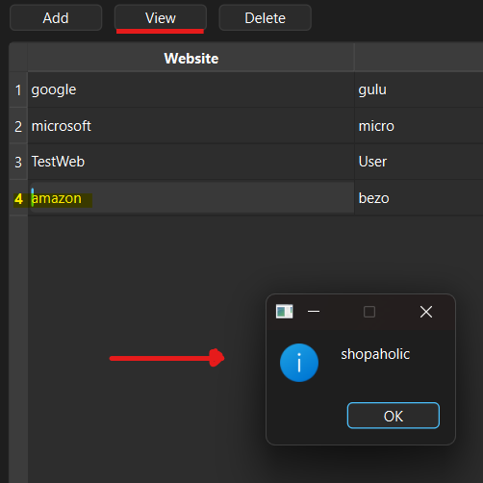

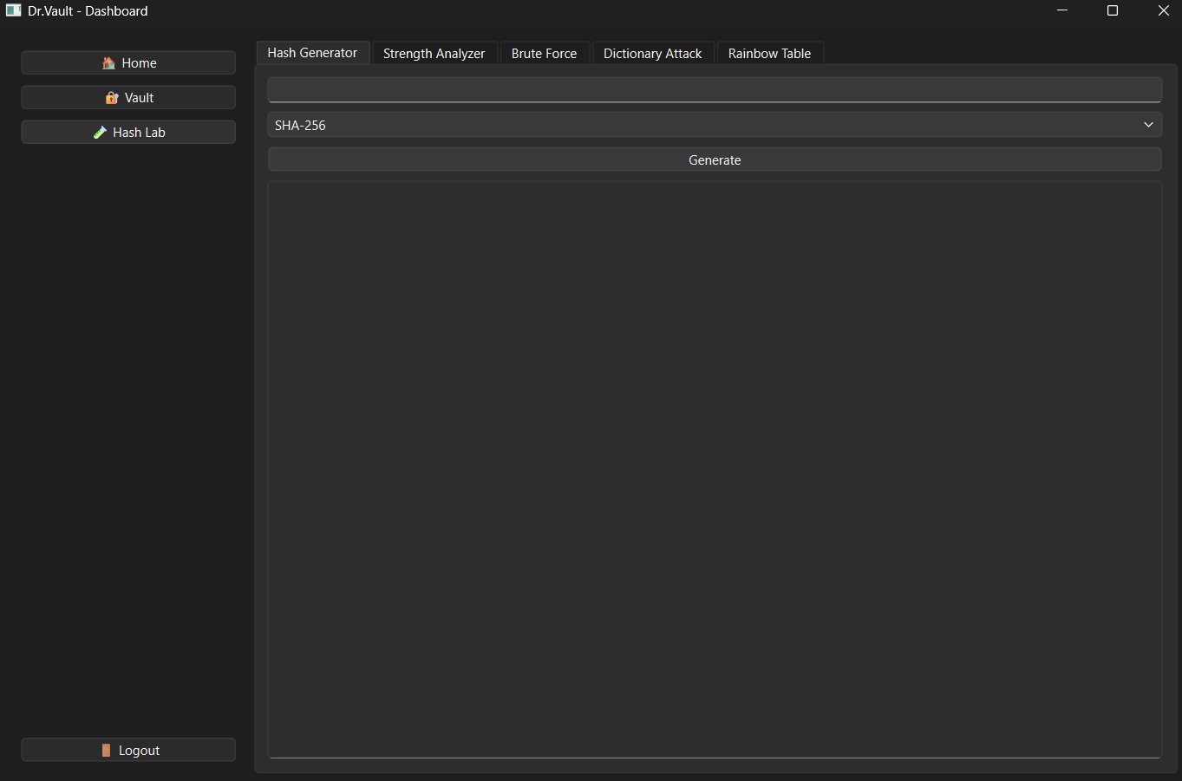

The Hash Lab:-
This tab contains several functions that the Users can try
Hash Generator – Can generate hash for SHA-256, SHA-512, MD5, bcrypt, base56
Strength Analyzer – Password strength analyzer that returns whether password is weak or strong
Brute Force – Basic level attack, can try brute forcing SHA-256,SHA-512,MD5
Dictionary attack – Uses Wordlist dictionary to crack password
Rainbow table – Uses rainbow table lookup to crack password

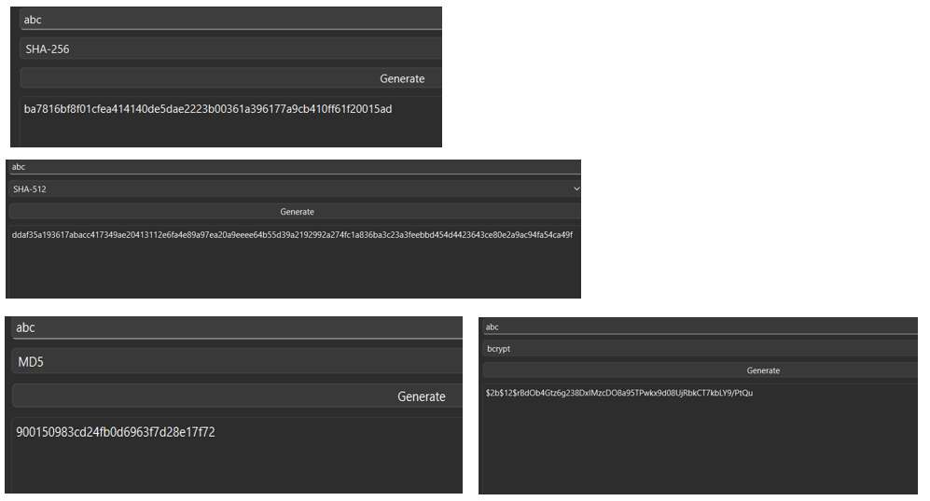
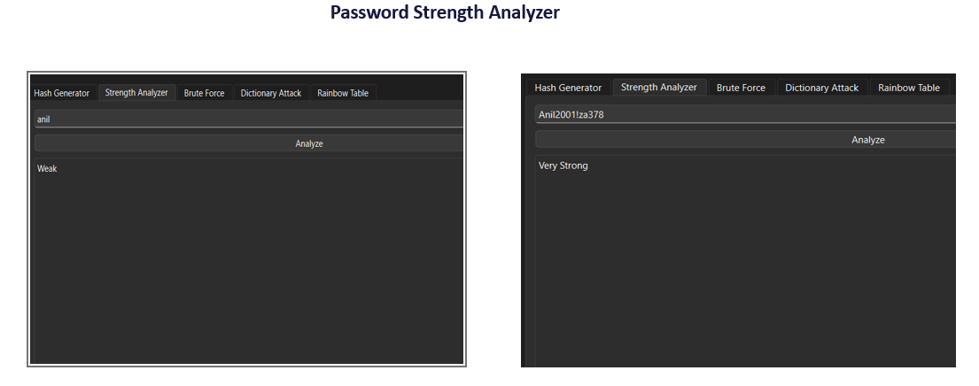

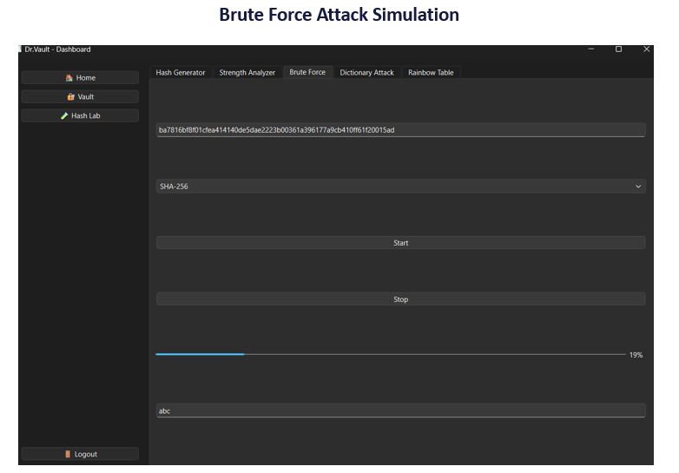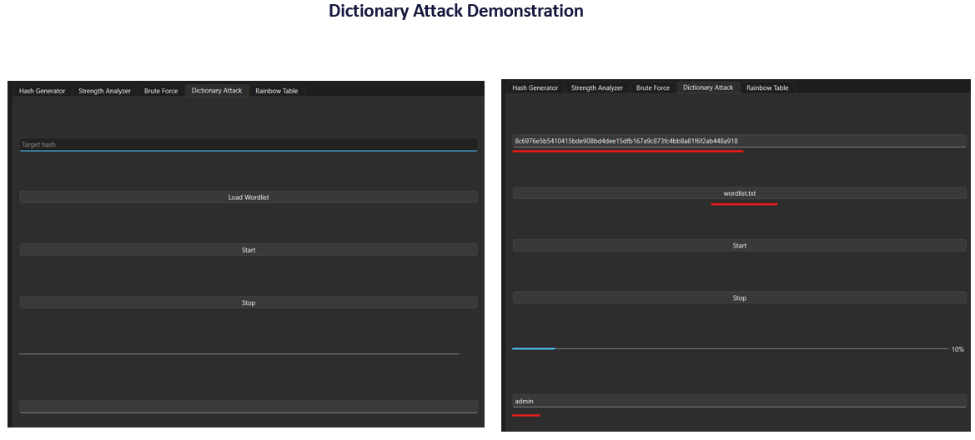

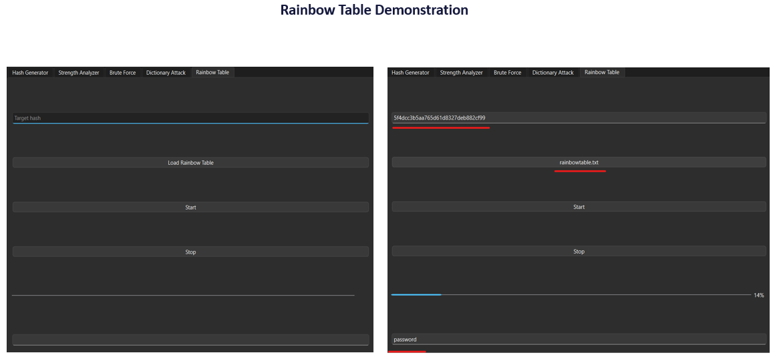

Conclusion and future
- Successfully completed the project scope and objectives- Build a secure password storage manager with user encryption and a basic password cracker tool.
- As a local low-end desktop running program - limited cracking performance compared to GPU-based tools. Cracking computationally intensive to the text files used.
- Similarly no distributed cracking or cloud acceleration
- Rainbow tables and dictionary attack word lists are size-constrained for demonstration purposes
Future Scope
- GPU acceleration (CUDA/OpenCL support) , distributed, cloud based cracking.
- Advanced password strength analytics and cracking using AI/ML models can be implemented

References
- PySide6 (QT for python) – GUI development in python: https://doc.qt.io/qtforpython-6/
- Crypto.Cipher package – AES Encryption: https://pycryptodome.readthedocs.io/en/latest/src/cipher/cipher.html
- Hashlib - https://docs.python.org/3/library/hashlib.html
- Bcypt - https://pypi.org/project/bcrypt/
- https://markilott.medium.com/password-storage-basics-2aa9e1586f98
- HashiCorp- latest in the market vault provider - https://developer.hashicorp.com/vault

